**Evaluation strategy:**

This document will contain two evaluation strategies to evaluate both the web and mobile app.

***Web evaluation strategy:***

**Structure**

• Is the site layout easy to understand and use?

• Can you navigate readily from page to page?

• Is it easy to get back to Home page?

**Use of Color**

• Are colors attractive and appealing to most users?

• Would more color aid the visitor in understanding the content?

**Readability**

• Are the pages easy for the users to read?

• Do the page elements follow a logical sequence?

• Are type fonts readable, attractive and properly sized?

**Page Layout**

• Is there a good use of "white space"?

• Do the graphics add to or detract from readability?

• Are elements sized and arranged to fit within browser window?

***Mobile app evaluation strategy:***

**Structure**

• Can you navigate readily from page to page?

• Is it easy to get back to Home page?

**Use of Color**

• Are colors attractive and appealing to most users?

• Would more color aid the visitor in understanding the content?

• Are appropriate colors used for a soothing effect?

• Are there a good color palette and a good color relationship? Does the color palette appeal to the target audience?

**Buttons**

• Are the buttons easy to spot and to tap?

• Do buttons have a strong contrast between text and background colors?

**Navigation**

• Are the number of categories and levels of navigation appropriate?

• Are categories arranged well based on priority, with the most important categories being the most prominent?

• Are there clear, concise and consistent labels for navigation throughout the application?

**Consistency**

• Are visual factors used consistently on every page?

**Alignment**

• Are groups of elements and texts aligned appropriately?

• Does the alignment establish an appropriate hierarchy of information?

**Typography**

• Is the number of fonts for the application appropriate and logical?

• Does each color used for each text function appear the same on every page and are there an appropriate number of colors used for fonts?

• Are character spacing, word spacing, leading, margin spacing, and type size used appropriately regarding the function of the text, including no italic type?

**Readability**

• Are the pages easy for the users to read?

• Do the page elements follow a logical sequence?

Questions should be answered based on this scale from 1-6:

1 = Very poor

2 = Poor

3 = Mediocre

4 = Good

5 = Excellent

6 = Very Excellent

You can provide comments with your answer if you wish.

**Data**

The data that will be collected is quantitative data.

**Constraints**

1. The evaluation of the mobile app is preferred to be done on an iPhone X
2. The screen size for the computer that will run the desktop app should be preferably of size: 1024x768 px

**Important Notes**

The .vp files should be opened using justinmind.

It’s a free prototyping tool you should install it and make an account for it.

This is the link:

https://www.justinmind.com

To test the mobile app on a smartphone download the justinmind app on your smartphone then open the DHC mobile.vp file on justinmind then select view on device. Then on your smartphone select view on device then the prototype will launch.

To access different screens in the desktop app, you will have these different logins for different users:

Username: admin

Username: doctor

Username: recep

You should enter these usernames in the login page to access the different screens.

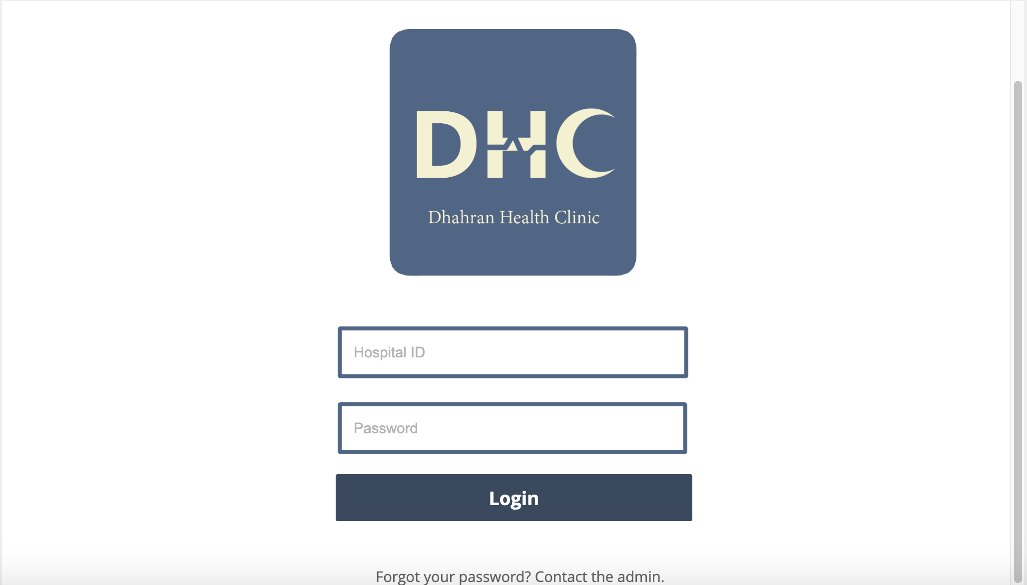

The password doesn’t matter.

For any clarification contact us through this email: s201617460@kfupm.edu.sa